RUNNING HEAD: Variation in Affect Valuation

Variation in Affect Valuation:

The Role of Interpersonal Goals

Emma Seppälä
Advisor: Jeanne Tsai
Department of Psychology
Stanford University

Abstract
Tsai, Knutson & Fung (2005) find that interpersonal goals partly mediate cultural differences in “affect valuation.” The present study examines the relationship between interpersonal goals and affect valuation. We focus on two types of interpersonal goals: influence (i.e. changing others to be consistent with the self) and adjustment (i.e. changing the self to be consistent with others). Because influence goals involve more action than adjustment goals, we predict that influence goals result in valuing high-activation positive states [HAP] (e.g., excitement, enthusiasm) more and low activation positive states [LAP] (e.g. calm, peacefulness) less than adjustment goals. To test this hypothesis, 15 Asian-American dyads and 17 European-American dyads are randomly assigned to “influence” and “adjustment” roles during a card-matching task; after the task, they switch roles and complete the task again. As predicted, when participants move from adjustment to influence roles, they valued HAP more and LAP less; when participants move from influence to adjustment roles, they value LAP more and HAP less. We discuss the implications of our findings for cultural differences in affect valuation.
Variation in Affect Valuation: The Role of Interpersonal Goals

Tsai, Knutson & Fung (2005) found cultural differences in “affect valuation” or the affective states that people value. They also found that interpersonal goals partly mediate cultural differences in affect valuation. In order to test the hypothesis that, at a cultural level, a causal relationship between interpersonal goals and affect valuation exists, the following study examined whether, at a situational level, a causal relationship between interpersonal goals and affect valuation exists.

Cultural Differences in Affect Valuation
Actual affect does not seem to differ significantly across cultures.
Researchers argue that many aspects of emotion are universal. For instance, emotional responses to prototypical events, components of emotional responding, (e.g. facial and vocal patterns, fight or flight mechanisms, autonomic activation patterns), certain mechanisms of emotion regulation, and emotional concerns appear to be similar across cultural contexts (Scherer & Wallbott, 1994; Scherer, 1997; Mesquita & Frijda, 1992). Moreover, the facial expressions corresponding to basic emotions are recognized universally (Ekman, 1972; Gudykunst, Ting-Toomey, 1988). Most recently, Tsai et al. (2005) have found few cultural differences in reports of affective experience.
Ideal affect does differ significantly across cultures.
While many aspects of emotional experience do not seem to vary across cultures, attitudes towards and feelings about emotions do appear to vary across cultural contexts (Gudykunst & Ting-Toomey, 1988). Tsai et al. (2005) have performed the most detailed research on this topic, with an emphasis on valued emotional states, which they coin “affect valuation.” Both East Asian and American cultural contexts value positively valenced states, like happiness. However, when individualistic cultures are compared to collectivistic cultures, individualistic cultures (e.g. European-Americans) tend to value high-activation positive states, like excitement, while collectivistic cultures (e.g. Hong Kong Chinese) tend to value low-activation positive states, like calm. Chinese-Americans, who have been exposed to both cultural contexts, value low-activation positive states more than European-Americans and value high-activation positive states more than East Asians. These findings suggest that cultural factors shape affect valuation.
In order to understand why these cultural differences in affect valuation exist, it is important to identify the factors that may account for these differences. As mentioned above, Tsai et al. (2005) found some evidence that cultural differences in interpersonal goals partly mediated cultural differences in affect valuation.

Cultural Differences in Interpersonal Goals
Self-schemas vary as a function of context
In order to understand cultural differences in interpersonal goals and how these differences might be related to cultural differences in affect valuation, it is important to first review cultural differences in self-schemas. The self-schema, also called self-construal or self-way, (Markus, 1977; Markus & Kitayama, 1991, Markus, Mullally & Kitayama, 1997) represents the knowledge that an individual has about him or herself (regarding cognition, emotion, and behavior) in relation to the environment. The self-schema is fluid and malleable and adapts to the expectations of different socio-cultural contexts (Markus et al. 1997). In individualistic cultures, such as the US, the self-schema is defined by its independence and autonomy from others (Markus & Kitayama, 1991). In collectivistic cultures, such as China, the self-schema is defined in terms of its interdependence with others and its group membership.
Interpersonal interactions teach and reinforce these self-schemas
Individuals learn how to construct their selves through interpersonal interactions within a cultural context. Markus et al. (1997, p.48) describe this process of “selving” as “a dynamic collective behavioral process, that necessarily occurs with relation to others, and through cultural participation.” Through interaction with others, individuals perceive others, are perceived by others, and reflectively perceive themselves (Gerson & Preiss, 1985; Goffman, 1955), thereby learning to construct their identities and behavior according to social expectations. For example, starting from childhood, individuals learn the emotional displays that are acceptable or desirable in different contexts (Ekman, 1972). Parents pay attention to and regulate the affective states of pre-school children (Maccoby, 1984; Maccoby & Martin, 1983) in order to socialize their children according to valued cultural norms (Hartup, 1989; Ogbu, 1981). Just as children learn to regulate affective states to social norms through positive and negative reinforcement (Eid & Diener, 2001), adults continue to adapt their self-schemas to their context in order to obtain positive reinforcement. They seek to put their “best foot forward” to create identities that will be valued in a social context (Baumeister, 1982, Jones & Pittman, 1982, Schlenker, 1980; Tetlock & Manstead, 1985) and that will afford them the most social rewards (Cooley, 1902; Goffman, 1959; Mead, 1934; Stryker, 1980; Stryker & Serpe, 1982). In this way, the social norms for affect and behavior are taught, reinforced, and maintained within a cultural context.
Interpersonal goals vary as a function of self-schemas
Interpersonal interaction is goal-oriented (Athay & Darley, 1981, Swann, 1984). Self-schemas, as representations of the self in its relation to others, shape interpersonal goals. Because self-schemas vary as a function of context, so do their corresponding interpersonal goals. Individualistic and collectivistic viewpoints present the most striking example of cultural differences in self-schemas and their corresponding interpersonal goals. Individualistic cultures emphasize influence goals, while collectivistic cultures emphasize adjustment goals.
As mentioned above, in individualistic cultures, such as the US, the self-schema is characterized by its independence and autonomy from others. The norm is to pursue one’s own goals and fulfill one’s own needs. Individuals therefore focus on their own feelings, thoughts and behavior. (Markus & Kitayama, 1991; Markus, Kitayam, & Heiman, 1996; Rothbaum, Weisz & Snyder, 1982; Weisz, Rothbaum & Blackburn, 1984; Morling & Fiske, 1999). American relationships strive on “relational challenge:” emphasis is placed on personal differences and independence (Rothbaum, Pott, Azuma, Miyake & Weisz, 2000). Individualistic cultures expect individuals to be emotionally independent of one another, emotions are displayed more often, and negative emotions are expressed directly. Therefore, people in individualistic cultures can be described as having influence goals, which refer to “standing out,” asserting one’s personality, and making an impact on the situation i.e. changing the environment to fit the needs of the self (Gudykunst & Ting-Toomey, 1988; Weisz et al., 1984; Morling, Kitayama, & Miyamato, 2002).
On the other hand, in collectivistic cultures, such as China, the self-schema is characterized by interdependence with others and group membership. The goal is to maintain cohesion and harmony within the group, to conform to social duties, and to support others’ needs in the group. Individuals therefore pay great attention to the emotions, thoughts, and behavior of others (Markus & Kitayama, 1991; Markus et al, 1996; Morling & Fiske, 1999; Rothbaum et al., 1982; Weisz et al., 1984). Indeed, Japanese relationships thrive on the state of symbiosis. Rather than relational challenge, individuals seek close-knit union and harmonious stability in their relationships with one another (Rothbaum et al., 2000). Emotional dependence on one another is assumed and in order to maintain the harmony of the group or the relationship, the display of emotions, and of negative emotions in particular, is minimized. Thus, people in collectivistic contexts have adjustment goals, which refer to “fitting in,” adapting themselves to the best interest of the group, and minimizing their impact on the situation i.e. changing the self to fit the needs of the environment (Gudykunst & Ting-Toomey, 1988; Weisz et al., 1984; Morling et al, 2002).
Links to Affect Valuation
Influence and adjustment goals involve different levels of activation. While influence goals require immediate action in order to impact the situation and change others, adjustment goals require suspended action so that individuals can decipher the particular demands of the situation and the needs of others around them. Indeed, research by Galinsky, Gruenfeld & Magee (2003) suggests that influence goals are linked to significantly more action.
Because influence and adjustment goals involve different levels of activity, we hypothesized that people with influence goals would value high-activation positive states [HAP] whereas people with adjustment goals would value low-activation positive states [LAP]. This hypothesis would explain why, in individualistic societies, where the primary goal is to influence others, HAP states are highly valued; and in collectivistic societies, where the primary goal is to adjust to others, LAP states are highly valued.
The Proposed Study
The proposed study seeks to investigate the hypothesis that cultural differences in affect valuation may be due to cultural differences in interpersonal goals. A previous study using an experimental manipulation (Tsai & Miao, 2005) supported this hypothesis. By manipulating interpersonal goals in a between-subjects experimental design, the authors found that they could manipulate affect valuation in the predicted direction. Specifically, participants endorsing influence goals valued HAP while participants endorsing adjustment goals valued LAP. The aim of the current study was to see if these relationships between interpersonal goals and affect valuation exist when interpersonal goals are manipulated within-subjects. Because within-subjects designs allow better control of possible confounds than between-subjects designs, we believed that a within-subjects design would provide a more powerful test of our hypotheses. Specifically, participants were randomly assigned to “influence” or “adjustment” roles while they completed a card-matching task. Half-way through the task, they completed a measure of affect valuation. During the second task, participants switched roles. Again, they completed the measure of affect valuation half-way through the task.

Method
Hypotheses
We hypothesized that when participants moved from endorsing adjustment to influence goals, they would show an increase in their desire for HAP states and a decrease in their desire for LAP states. We also predicted that when participants moved from endorsing influence to adjustment goals, they would show an increase in their desire for LAP states and a decrease in their desire for HAP states.
Participants
17 European-American female dyads and 15 Asian-American female dyads participated in a “mood and puzzle solving study” for pay or partial class credit. Participants were Stanford undergraduates between the ages of 18 and 24 (Mean age = 19.4 , SD = 1.6 ). Participants were first screened to ensure that they met the study criteria. Specifically, European-Americans were required to 1) have been born and raised in the U.S., 2) have parents born and raised in the U.S., and 3) be of Northern European decent. Asian-American dyads were required to 1) be born and raised either in the US or East Asia (China, Korea, or Japan), and 2) have parents born and raised in East Asia. If the participants were acquainted with one other, they were not allowed to participate in the study together.
Instruments
Affect Valuation
To assess participants’ affect valuation (or “ideal affect”), we administered the Affect Valuation Index (AVI; see Appendix A), which is reliable and valid in American and Chinese student populations (Tsai & Knutson, 2005). In its original form, the AVI asks participants to rate how much they would “IDEALLY like to feel” each of 28 emotions “on average.” Items sample each octant of the affective circumplex. However, for the purposes of the present study, we adapted the AVI in three ways. First, due to time constraints, we used an abbreviated form of the AVI that included 16/28 emotions. Although all octants of the affective circumplex (Watson & Tellegan, 1985) were represented, emotions corresponding to HAP and LAP were overrepresented because of their significance to our hypotheses. Second, we also adapted the instrument to assess affect valuation in the moment; that is, we asked them to rate how much they would “IDEALLY like to feel” each emotion “right now.” Third, to achieve greater variability in responding, we used a 7-point instead of a 5-point scale.
To control for affect experienced during the task, we added a measure of affective experience (“actual affect”). The measure was identical to the adapted measure of the AVI described above; however, instead of asking participants how much they would IDEALLY like to feel, we asked participants to rate how much they “ACTUALLY feel” each emotion “right now.”
For both measures of actual and ideal affect, we first ipsatized the scores (to control for differences in response styles) and then calculated mean aggregates for each octant. Then we calculated within-subjects change scores measuring the extent to which actual and ideal affect changed from one role to the other. For example, for each participant going from the influencer role to the adjuster role, we subtracted 1) the ideal LAP that she endorsed in the influencer role from the ideal LAP she endorsed in the adjuster role and 2) the ideal HAP she endorsed in the influencer role from the ideal HAP she endorsed in the adjuster role. For each participant going from the adjuster role to the influencer role, we subtracted 1) the ideal LAP she endorsed in the adjuster role from the ideal LAP she endorsed in the influencer role and 2) the ideal HAP she endorsed in the adjuster role from the ideal HAP she endorsed in the influencer role.
Interpersonal Goals
In order to assess whether the roles influenced the participant’s goals in the predicted direction, we administered Locke’s Circumplex of Interpersonal Values (2000; see Appendix B) as a manipulation check. Participants were asked to rate, on a Likert scale of 0 (“not at all”) to 4 (“extremely”), “HOW IMPORTANT” it was to them that they acted or appeared, or were treated a certain way by their partner. We ipsatized the scores and then used mean aggregates for items related to influence goals (e.g. “It is important that I have an impact on them,” “they acknowledge when I am right,” “they listen to what I have to say”) and items related to adjustment goals (e.g. “It is important that I do what they want me to do,” “They not see me as getting in their way,” “I go along with what they want to do,” “I do what they want me to do”).
We then calculated within-subjects change scores measuring the extent to which interpersonal goals changed when participants switched from one role to the other. For each participant going from the influencer role to the adjuster role, we subtracted 1) the influence goals that she endorsed in the influencer role from those she endorsed in the adjuster role, and 2) the adjustment goals that she endorsed in the influencer role from those she endorsed in the adjuster role. For each participant going from the adjuster role to the influencer role, we subtracted 1) the influence goals she endorsed in the adjuster role from those she endorsed in the influencer role, and 2) the adjustment goals that she endorsed in the adjuster role from those she endorsed in the influencer role.
Procedure
The study consisted of an experimental laboratory session. When participants arrived in the laboratory room, the experimenter ensured that they were not acquainted with one another. The participants were then seated across from one another with a table in between them. A screen was placed on the table between the participants so that they could not see each other’s work. The participants filled out questionnaires that assessed actual and ideal affect during baseline (or before any experimental instruction). Both participants were then each given an identical set of 11 cards (tangram figures). They were told to select 9 of these cards that they thought went well together and to place them in an order that made the most sense to them on a grid.
Card-Matching Task
After the participants had completed this first task, the experimenter randomly assigned them to either “Role A” (the influencer role) or “Role B” (the adjuster role) by picking one of two cards out of a bowl. The role picked out of the bowl was always assigned to the person sitting near the wall. After hearing a description of their role, the participants were asked to summarize their role in one or two written sentences on a sheet of paper. The adjuster was then asked to undo the card order she had chosen (to simulate abandoning personal preference in order to adjust to another person’s preference).
The following task was modeled after a communication task designed by Schober and Clark (1989). The influencer verbally described each card in her chosen order to her partner. The adjuster attempted to guess which card the influencer was describing, one at a time, so that she could replicate the order of the cards on her grid. The adjuster was instructed to get into her partner (the influencer)’s frame of mind. When she thought she knew which card the influencer was describing, she held it up above the screen to show the influencer. If the adjuster was incorrect, the influencer would describe the card again until the adjuster guessed correctly. If the adjuster was correct, the influencer would begin describing the next card. Participants in the influencer role were expected to endorse influence goals more than adjustment goals because they had a direct impact on the follower’s behavior through their instructions. Participants in the adjustment role were expected to endorse adjustment goals more than influence goals because they were required to pay attention to the influencer’s instructions and behave as directed.
When the participants reached the 7th card, the experimenter, who was watching them on a TV screen in an adjacent room, interrupted the participants to fill out another measure of actual and ideal affect. The participants then completed the card-matching task. When finished, they filled out the Interpersonal Goals measure (Circumplex Scales of Interpersonal Values Scale, Locke; 2000) as a manipulation check.
The participants then worked on a word scramble with neutral words (e.g. “giraffe,” “aircraft”) to clear their minds of the first part of the study. During the second part of the study, participants again appeared to be “randomly” assigned to their roles. However, the experimenter ensured that their roles were reversed. The participants were again asked to describe their roles on a piece of paper. Then they performed the card-matching task again with their new roles. Again, measures of actual and ideal affect were administered in the middle of the task, and the measure of interpersonal goals was administered at the end of the task

Results

Manipulation Check
To assess whether the manipulation was successful in eliciting influence and adjustment goals, we conducted a 2 [Ethnicity (European-American, Asian-American)] X 2 [Change in Role (Adjuster to Influencer, Influencer to Adjuster)] X 2 [Interpersonal Goals (Influence, Adjustment)] repeated measures analysis of variance. Ethnicity was a between-subjects factor, Change in Role and Interpersonal Goals were within-subjects factors. As predicted, the experimental manipulation was successful: the Change in Role x Change in Interpersonal Goal interaction was significant (F [1, 30] = 71.19, p < .01). When participants moved from an adjustment role to an influence role, their adjustment goals decreased and their influence goals increased; when participants moved from an influence role to an adjustment role, their influence goals decreased and their adjustment goals increased. Pair-wise t-test comparisons show that when influencers became adjusters, their influence goals were significantly different from their adjustment goals (t [31] = -5.036, p < .01); when adjusters became influencers, their influence goals were significantly different from their adjustment goals (t [31] = 6.864, p < .01). Furthermore, the influence goals of influencers who became adjusters were significantly different from the influence goals of adjusters who became influencers (t [31] = -.6.952, p < .01), and the adjustment goals of influencers who became adjusters were significantly different from the adjustment goals of adjusters who became influencers (t [31] = 8.548, p < .01).
<Insert Figure 1 here>
Results
To test our predictions about the relationship between interpersonal goals and affect valuation, we conducted a 2 [Ethnicity (European-American, Asian-American)] X 2 [Change in Role (Adjuster to Influencer, Influencer to Adjuster)] X 2 [Ideal Affect (HAP, LAP)] repeated measures analysis of variance. Ethnicity was a between-subjects factor; Change in Role and Ideal Affect were within-subjects factors. The results supported our hypotheses: the Change in Role x Change in Ideal Affect interaction, controlling for actual affect, was significant (F [1, 36] = 4.68, p < .05). As predicted, when participants moved from an adjustment role to an influence role, their ideal HAP increased and their ideal LAP decreased. Pair-wise t-test comparisons revealed that when adjusters became influencers, their ideal HAP was significantly different from their ideal LAP (t [31] = 2.545, p < .05); when participants moved from an influence role to an adjustment role, their ideal LAP increased. Pair-wise t-test comparisons also revealed that when influencers became adjusters, their ideal HAP was not significantly different from their ideal LAP (t [31] = -.672, p > .05). Contrary to our hypothesis, the change score for their ideal high-activation positive states increased, although this increase was not significantly different from `0, (t [32] = .577, p > .05, see Figure 2). In addition, the ideal HAP of influencers who became adjusters was significantly different from the ideal HAP of adjusters who became influencers, (t [31] = -.2.097, p < .05); the ideal LAP of influencers who became adjusters was significantly different from the ideal LAP of adjusters who became influencers (t [31] = 2.367, p < .05)

Although there was a main effect of Ethnicity (F [1, 26] = 11.963, p < .01), there were no significant interactions with Ethnicity. Asian-Americans endorsed more affect than European Americans (European-American M = .002, SE = .016; Asian-American M = .095, SE = .017).
<Insert Figure 2 here>

Discussion
As predicted, when moving from adjustment to influence goals, individuals increase in their ideal HAP and decrease in their ideal LAP; when moving from influence to adjustment goals, individuals increase in their ideal LAP. These findings provide further evidence that interpersonal goals are causally linked to affect valuation.
These situational findings lend support to the idea that, on a cultural level, differences in the endorsement of interpersonal goals may account for differences in Affect Valuation. In Chinese contexts, the fact that adjustment goals are endorsed more chronically may be one of the reasons why LAP are valued more highly than in American contexts. In American contexts, the fact that influence goals are endorsed more chronically may be one of the reasons why HAP are valued more than in Chinese contexts.

Limitations & Future Directions
Cultural Context
One limitation of the findings is that, contrary to hypothesis, individuals moving from an influence goal to an adjustment goal did not decrease in their ideal HAP states (in addition, there was not a significant difference between the change in ideal HAP and the change in ideal LAP for this group). These findings may be due to the fact all participants belonged to an American cultural context, which emphasizes HAP. Participants who are initially placed in a role that reinforces their culturally valued affect may be more resistant to changing their valued state. If the above explanation is correct, then in a Chinese context, where LAP are more highly valued, we should find a complementary pattern. When participants move from an influence to an adjustment goal, we predict an increase in ideal LAP and a decrease in ideal HAP. When participants move from an adjustment to an influence goal, however, we predict an increase in ideal HAP and no change in ideal LAP. In order to address this hypothesis, we plan to collect data in Hong Kong this fall.
Asian-Americans endorsed more affect than European-Americans overall. This finding may be due to the fact that Asian-Americans, by being bicultural, have a more expansive affective experience. The global Affect Valuation findings show that Asian-Americans value high-activation positive states as much as European-Americans, and value low-activation positive states as much as Hong-Kong Chinese. As such, their ideal affective range is broader than either cultural group. This fact may explain why, in our findings, Asian Americans valued more emotions overall than European Americans did. Similar studies with other bicultural groups will help to further clarify this hypothesis.
Gender
Another limitation of our study is that the participants were all female. On a global level, few gender differences in affect valuation have been observed. However, pilot findings with our between-subject card-matching study show that the manipulation is not successful for men: although the interpersonal goals manipulation was successful, the men tended to value mostly high-activation positive states, regardless of their roles. One possible explanation for this finding is men’s different conception of “adjuster” roles. Men conceive of adjuster roles as a means to becoming an influencer. This could explain why, even as adjusters, men value HAP. Another possible explanation is that the card-matching task is not “masculine” enough. For this reason, we are currently running a similar study using lego blocks. This task is proving more popular with male participants than the card-matching task.

Conclusion
Previous findings suggest that collectivistic and individualistic cultures differ in their Affect Valuation. Collectivistic cultures value LAP, whereas individualistic cultures value HAP. The present research attempted to investigate the mediating role of interpersonal goals in cultural differences in Affect Valuation by examining the relationship between interpersonal goals and affect valuation within-subjects. Consistent with our hypotheses, even within subjects, adjustment goals resulted in a preference for low-activation positive states while influence goals resulted in a preference for high-activation positive states.
References

Athay, M., & Darley, J. M. (1981). Toward an interaction-centered theory of personality. In N. Cantor & J. F. Kihlstrom (Eds.), Personality, Cognition, and Social Interaction (pp. 281-308). Hillsdale, NJ: Erlbaum.

Baumeister, R. (1982). A self-presentational view of social phenomena. Psychological Bulletin, 91, 3-26.

Cooley, C. H. (1902). Human Nature and Social Order. New York: Scribner’s.

Eid, M., Diener, E. (2001). Norms for experiencing emotions in different cultures: Inter- and Intranational Differences. Journal of Personality and Social Psychology, 81, 869-885.

Ekman, P., Friesen, W. V., Ellsworth, P. (1972). Emotion in the Human Face. New York: Pergamon.

Galinsky, A. D; Gruenfeld, D. H; Magee, J. C., (2003). From Power to Action. Journal of Personality and Social Psychology, 85, 453-466

Gerson, J. M., & Preiss K. (1985). Boundaries, negotiation, consciousness: Reconceptualizing gender relations. Social Problems, 32, 317-331.

Goffman, E, (1955). On face-work: An analysis of ritual elements in social interaction. Psychiatry, 18, 213-231.

Goffman, E. (1959). The presentation of self in everyday life. New York: Anchor Books.

Gudykust, W. B., Ting-Toomey, S. (1988). Culture and affective communication. American Behavioral Scientist, 31, 3, 384-400.

Hartup, W. W. (1989). Social relationships and their developmental significance. American Psychologist, 44, 120-126.

Harwood, R. L. (1992). The influence of culturally derived values on Anglo and Puerto Rican mothers’ perceptions of attachment behavior. Child Development, 63, 822-839.

Harwood, R. L., & Miller, J. G. (1991). Perceptions of attachment behavior: A comparison of Anglo and Puerto Rican mothers. Merrill-Palmer Quarterly, 37, 583-599.

Holtgraves, T., (1997). Styles of Language Use: Individual and Cultural Variability in Conversational Indirectness. Journal of Personality and Social Psychology, 73, 624-637.

Jones, E. E., Pittman, T. S. (1982). Toward a general theory of strategic self-presentation. In J. Suls (Ed.), Psychological perspectives on the self (Vol. 1, pp. 231-262). Hillsdale, NJ: Erlbaum.

Leung, K. (1987). Some determinants of reactions to procedural models for conflict resolution: A cross-national study. Journal of Perosnality and Social Psychology, 53, 898-908.

Leung, K., Lind, E. A. (1986). Procedural justice and culture: Effects of culture, gender, and investigator status on procedural preferences. Journal of Personality and Social Psychology, 50, 1134-1140.

Leung, K. (1987). Some determinants of reactions to procedural models for conflict resolution: A cross-national study. Journal of Personality and Social Psychology, 53, 898-908.

Locke, Kenneth D. (2000). Circumplex scales of interpersonal values: Reliability, validity, and applicability to interpersonal problems and personality disorders. Journal of Personality Assessment, 75, 249-267.

Maccoby, E. E., (1984). Socialization and development change. Child Development, 55, 317-328.

Maccoby, E. E., & Martin, J. A. (1983). Socialization in the context of the family: Parent-child interaction. In E. M. Hetherington (Ed.), Handbook of child psychology: Socialization, personality, and social development (Vol. 4, pp. 1-101). New York: Wiley

Markus, H. R., Mullally, P. & Kitayama, S. (1997) Selfways: Diversity in modes of cultural participation. In Neisser U. & Jopling D.(Eds.). The conceptual self in context: Culture, experience, self-understanding. The Emory symposia in cognition (pp. 13-61). New York: Cambridge University Press.

Markus, H. R., Kitayama, S., (1991). Culture and the Self: Implications for cognition, emotion, and motivation. Psychological Review, 98, 224-253.

Markus, H. R., Kitayama, S., R., Heiman, R. J., (1996). Culture and “basic” psychological processes. In: Higgins, E. T., Kruglanski, A. W. (Eds); Social psychology: Handbook of basic principles.(pp. 857-913); New York: Guilford Press.

Markus, H. R. (1977). Self-schemata and processing information about the self. Journal of Personality and Social Psychology, 35, 63-78.

Mead, G. H. (1934). Mind, Self, and Society. Chicago: University of Chicago Press.

Mesquita, B. & Frijda, N. H. (1992). Cultural variations in emotions: A review. Psychological Bulletin, 112, 179-204.

Miyake, K., Chen, S. J., Campos, J. J. (1985). Infant temperament, mother’s mode of interaction, and attachment: an interim report. Monographs of the Society for Research in Child Development, 50, 276-297.

Morling, B., Fiske, S. T., (1999). Defining and measuring harmony control. Journal of Research in Personality, 33, 379-414.

Morling, B., Kitayama, S., Miyamoto, Y. (2002). Cultural practices emphasize influence in the United States and adjustment in Japan. Personality & Social Psychology Bulletin. 28, 311-323

Ogbu, J. U. (1981). Origins of human competence: A cultural-ecological perspective. Child Development, 52, 413-429.

Rothbaum, F., Weisz, J. R., Snyder, S. S., (1982). Changing the world and changing the self: A two-process model of perceived control. Journal of Personality and Social psychology, 42, 5-37.

Rothbaum, F., Pott, M., Azuma, H., Miyake, K., Weisz, J. (2000). The Development of Close Relationships in Japan and the United States: Paths of Symbiotic Harmony and Generative Tension. Child Development, 71, 1121-1142.

Sanchez-Burks, J., Lee F., Choi, I., Nisbett, R., Zhao, S., Koo, J., (2003). Conversing across cultures: East West communication styles in work and nonwork contexts. Journal of Personality and Social Psychology, 85, 365-362.

Scherer, K., Wallbott, H. G. (1994). Evidence for universality and cultural variation of differential emotion response patterning. Journal of personality and Social Psychology, 66, 310-328.

Scherer, K. R. (1997). The role of culture in emotion-antecedent appraisal. Journal of Personality and Social Psychology, 66, 310-328.

Schlenker, B. R. (1980). Impression management: The self-concept, social identity and interpersonal relations. Monterey, CA; Brooks/Cole.

Schober, M.F. & Clark, H. H. (1989). Understanding by addressees and overhearers. Cognitive Psychology, 21, 211-232.

Sue, D. W. (1990). Culture-Specific Strategies in Counseling: A Conceptual Framework. Professional Psychology: Research and Practice, 21, 424-433.

Stryker, S. (1980). Symbolic Interactionism. Menlo Park, CA: Benjamin/Cummings.

Stryker, S., & Serpe, R. T. (1982). Commitment, identity salience, and role behaviors: theory and research examples. In W. J. Ickes & E. S. Knowles (Eds.), Personality roles and social behavior (pp. 199-218). New York: Springer-Verlag.

Swann, W. B., Jr. (1984). Quest for accuracy in person perception: A matter of pragmatics. Psychological Review, 91, 457-477.

Swann, W. B., Jr. (1984). A battle of wills: Self-verification versus behavioral confirmation. Journal of Personality and Social Psychology, 46, 1287-1302.

Tetlock, P. E., & Manstead, A. S. R. (1985). Impression management versus intrapsychic explanations in social psychology: A useful dichotomy? Psychological Review, 92, 59-77.

Tsai, J. L., Knutson, B. K., Fung, H. H. (2005). Cultural variation in Affect Valuation.

Tsai, J. L., Knutson, B. K. (2005). The Affect Valuation Index: Reliability and validity.

Wade-Benzoni, K. A., Okumura, T., Brett, J. M, Moore, D. A., Tenbrunsel, A. E., Bazerman, M. H. (2002). Cognitions and behavior in asymmetric social dilemmas: A comparison of two cultures. Journal of Applied Psychology, 87, 87-95.

Weisz, J. R., Rothbaum, F. M., Blackburn, T. C. (1984). Standing out and standing in: The psychology of control in America and Japan. American Psychologist, 39, 955-969.

Appendix A: Affect Valuation Index

Now, please rate how much you would IDEALLY LIKE TO FEEL each of the following feelings and emotions NOW. Use the following scale:

1 |  | 2 | 3 | 4 |  | 5 | 6 | 7
Not at all |  |  |  | Moderately |  |  |  | Extremely

Enthusiastic _____ | Sluggish _____ | Harmonious _____
Dull _____ | Quiet _____ | Nervous _____
Excited _____ | Content _____ | Relaxed _____
Alert _____ | Fearful _____ | Sad _____
Energetic _____ | Calm _____ | Happy _____
Still _____ | Unhappy _____ | Surprised _____

Appendix B: Interpersonal Goals Questionnaire
(Circumplex Scales of Interpersonal Values Scale, Locke, 2000)
Please use the following rating scale to indicate HOW IMPORTANT it was to you that you acted or appeared, or were treated in the indicated way while you were solving the tangram puzzles with your partner. If some of these items feel as if they don’t apply, please circle 0.

0 |  | 1 | 2 |  | 3 | 4
Not At All |  | Mildly | Moderately |  | Very | Extremely

When I am with this person, it was:

0 |  | 1 | 2 |  | 3 | 4 |  | important that I appear confident
0 |  | 1 | 2 |  | 3 | 4 |  | important that I have an impact on them
0 |  | 1 | 2 |  | 3 | 4 |  | important that I feel connected to them
0 |  | 1 | 2 |  | 3 | 4 |  | important that they not see me as getting in their way
0 |  | 1 | 2 |  | 3 | 4 |  | important that I go along with what they want to do
0 |  | 1 | 2 |  | 3 | 4 |  | important that I not make a social blunder
0 |  | 1 | 2 |  | 3 | 4 |  | important that they not know what I am thinking or feeling
0 |  | 1 | 2 |  | 3 | 4 |  | important that I appear forceful
0 |  | 1 | 2 |  | 3 | 4 |  | important that they acknowledge when I am right
0 |  | 1 | 2 |  | 3 | 4 |  | important that they listen to what I have to say
0 |  | 1 | 2 |  | 3 | 4 |  | important that they come to me with their problems
0 |  | 1 | 2 |  | 3 | 4 |  | important that they not reject me
0 |  | 1 | 2 |  | 3 | 4 |  | important that I do what they want me to do
0 |  | 1 | 2 |  | 3 | 4 |  | important that I not make mistakes in front of them
0 |  | 1 | 2 |  | 3 | 4 |  | important that I not show I care about them
0 |  | 1 | 2 |  | 3 | 4 |  | important that I attack back when I am attacked

Figure 1
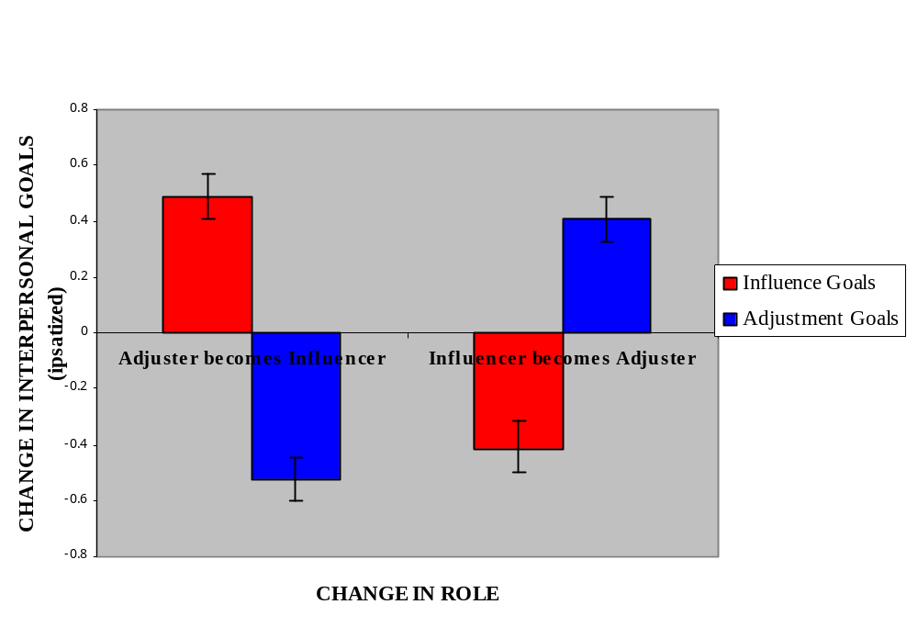

*
*

Figure 2
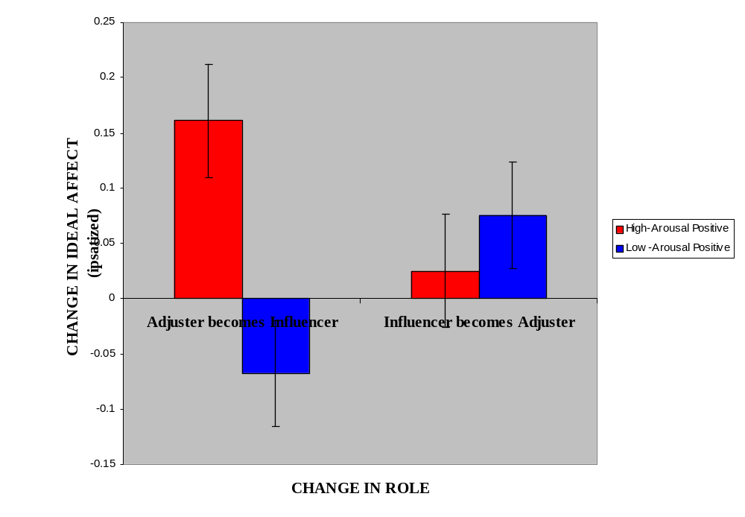

Figure Captions

Figure 1: Manipulation Check: increase and decrease of influence and adjustment goals as a function of role change.

Figure 2: Results: increase and decrease of ideal HAP and ideal LAP as a function of role change.

